A

PROJECT REPORT

ON

**Online Complaint System**

Towards partial fulfillment of the requirement in

**4th Semester** **BCA 2022**

**Submitted By: -**

200510101159 **-** Aman Kumar Singh

200510101164 **-** Roshani Singh

200510101169 **-** Mitanshi Solanki

**Submitted To:-**



**Parul Institute of Computer Application,**

**Parul University.**

Under the Guidance of

Dr. Kamini Solanki **(**Assistant Professor**)**

**Acknowledgement**

*The success and final outcome of this project required a lot of guidance and assistance from many people and we are extremely privileged to have got this all along the completion of our project. All that we have done is only due to such supervision and assistance and we would not forget to thank them.*

*I respect and thank Dr. Priya Swaminarayan, Dean, FITCS for providing us an opportunity to do the project work in BCA and giving us all support and guidance, which made us complete the project duly. We are extremely thankful to Mam for providing her support and guidance, although she had busy schedule managing the academic affairs.*

*We would not forget to remember Prof. Hina Chokshi, HOD, BCA department for her encouragement and more over for her timely support and guidance till the completion of our project work.*

*We owe our deep gratitude to our project guide* ***Dr. Kamini Solanki****, who took keen interest on our project work and guided us all along, till the completion of our project work by providing all the necessary information for developing a good system.*

*We are thankful to and fortunate enough to get constant encouragement, support and guidance from our Parents, all Teaching staffs of BCA Department which helped us in successfully completing our project work. Also, we would like to extend our sincere esteems to all staff in laboratory for their timely support.*

***[Aman Kumar Singh] [200510101159]***

***[Roshani Singh] [200510101164]***

***[Mitanshi Solanki] [200510101169]***



**PARUL INSTITUTE OF COMPUTER APPLICATION**

**CERTIFICATE**

This is to certify that **Aman Kumar Singh, Roshani Singh, Mitanshi Solanki** the student(s) of Parul Institute of Computer Application, has/have satisfactorily completed the project entitled **“Online Complaint System”** as a part of course curriculum in BCA semester-IV for the academic year 2021 under guidance of **Prof. Kamini Solanki (Assistant Professor)**

Enrollment Number: **200510101159**

Enrollment Number: **200510101164**

Enrollment Number: **200510101169**

|  |  |  |
| --- | --- | --- |
| **Quality of work** | **Grade** | **Sign of Internal guide** |
| **Poor / Average / Good /**  **Excellent** | **B /B+ / A / A+** |  |

Date of submission:

HOD, Principal,

Prof. Hina Chokshi Dr. Priya Swaminarayan

**INDEX**

|  |
| --- |
| **Content** **Page No.** |
| 1. Introduction to Project System 06 |
| 1. System Requirement Specification 07 |
| * 1. Introduction to SRS 07 |
| * 1. Hardware Requirement 07 |
| * 1. Software Requirement 07 |
| * 1. System Users 08 |
| * 1. Description of User Role 08 |
| * 1. System Features 08 |
| * 1. Description of Features 09 |
| * 1. Timeline Chart 10 |
| 1. System Flow Diagram 11 |
| 1. Data Dictionary  15 |
| 1. Screenshots of Development Phase -1 18 |
| 1. Screenshots of Development Phase -2 20 |
| 1. Screenshots of Development Phase -3 21 |
| 1. Conclusion 24 |
| 1. Future Enhancement 25 |
| 1. References 26 |

**ABSTRACT**

In this System, we are providing features like Login, Registration of users, forgot password option. Also features like upload media files (like Pictures, Audio Recordings and Video Recordings) features are there in this System. In this system Hyper Text Markup Language (HTML), Cascading Style Sheets (CSS) and JavaScript is used as front-end and Django Framework of Python 3.9.10 and SQL Server is used as back-end. In this System there is Simple GUI which support all browser.

This system is Password protected, So authorized user can only access to this system. In this system attractive User Interface (UI) are used which looks attractive to the User.

There is total two users in this system (Admin and User)  
Every user has their specific role in this System. For login into Admin and User portal Password is Required, user can also reset there if they forgot their password.

This System will be very beneficial for our Surrounding Security purpose due to its it’s feature of Storing permanent media and data that is putted by the user.

**Chapter: 01**

**INTRODUCTION**

Online Complaint System is the system which is developed using **PHP** Programming Language, **HTML, CSS, JavaScript** and **SQL Server**.

This system will be helpful for our neighbor, society and our Country by its feature of sending the media to the Local and State Government and Media, this will help our user by keeping them anonymous.

This system will be having some terms and conditions which user have to follow and if they will not follow that terms and conditions then user may be blocked or blacklist from the System, so they have to carefully follow the instructions of the System. User have to upload their media files according to the System rules and if they upload fake media files they will also be restricted from the System.

At the time of registration user have to put their username uniquely according to his\her choice.

System will never ask user personal documents like Aadhar, PAN etc, which put user as a an anonymous.

For login into Admin and User Portal System will ask for password. There is only one Admin and there can be multiple Users in this System. Every user has their Specific Task such as Admin having the access to manage all the users and Admin can approve the media’s which is uploaded by the user then it will be forwarded next to the official Mail ID of respective Government and Media. User can upload media files and they have to specify some details of that media file and then they can send the file after that they have to wait for admin confirmation then it automatically forwarded next, then user will get a confirmation of the media delivery.

**Chapter 2**

**System Requirement Specification**

**2.1 Introduction to SRS**

**2.1.1 What is SRS?**

A software requirements specification (SRS) is a description of a software system to be developed. It lays out functional and non-functional requirements, and may include a set of use cases that describe user interactions that the software must provide.

**2.1.2 Need of SRS**

In order to fully understand one’s project, it is very important that they come up with a SRS listing out their requirements, how are they going to meet it and how will they complete the project. It helps the team to save upon their time as they are able to comprehend how are going to go about the project. Doing this also enables the team to find out about the limitations and risks early on.

**2.2 Hardware Requirement**

|  |  |
| --- | --- |
| **Hardware Components** | **Specification** |
| Processor | Intel core I3,/I5 |
| RAM | 4GB/8GB |
| Hard disk or **SSD** | 512GB/1TB or **256GB** |
| Monitor | 15.6 colour monitor or advance |
| Device | Keyboard, Mouse |

**2.3 Software Requirement**

|  |  |
| --- | --- |
| **Name of component** | **Specification** |
| Operating System | Any Operating System |
| Software development kit | HTML, CSS, JavaScript, PHP Version 8.12, VS code, MySQL Server, Apache Server |
| Programming language | PHP [with Apache Server and MySQL Server]. |

**2.4 System Users**

2.4.1 Admin

2.4.2 User

**2.5 Description of User Role**

**2.5.1 Admin**

Admin can manage users and they can approve the user requests.

* + 1. **User**

User can upload media and specify the content of the media.

**2.6 System Features**

1. **Secure Login**
2. **Dashboard**
3. **Submit Complaints/Queries**
4. **View Complaints History**
5. **Update Account Details**
6. **Manage Complaints**
7. **View Complaint Details**
8. **Update Complaint Status**
9. **View List of Users**
10. **Manage Category**
11. **Manage Sub-Category**
12. **Manage State**
13. **View Users Login Logs**
14. **Update Account Password**

**2.7 Description of Features**

**2.7.1 Secure Login**

This System having a login username and password for users and every login detail can tracked by user, so its login is very secure.

**2.7.2 Dashboard**

This System having dashboard which gives all option to the user what the user wants to do in the System.

**2.7.3 Submit Complaints/Queries**

User can Submit their complaint according to himself/herself. This option is in User Dashboard. User can also upload media, in this section.

**2.7.4 View Complaints History**

User can also view their complain in the Complaint history section. Their he/she can check the current status of the Complain.

**2.7.5 Update Account Details**

User can also update their Account by adding addresses and by changing phone number etc.

**2.7.6 Manage Complaints**

Now Admin can only manage complaints which is filed by Users, Admin can also close the complaints on the basis of Complain type.

**2.7.7 View Complaint Details**

Admin can view Complaint details and their Admin can also check if there is any media uploaded by any user.

**2.7.8 Update Complaint Status**

In the Complaint details section, Admin can update the current status of the Complaint (like in process or closed).

**2.7.9 View List of Users**

Admin can also see the list of users and their Admin can also see detailed information about the User.

**2.7.10 Manage Category**

Admin can manage category like the topic of complain. Admin can update, add and delete the categories.

**2.7.11 Manage Sub-Category**

Admin can manage sub-category like the sub-topic of complain based on topic chosen by the user. Admin can update, add and delete the sub-categories.

**2.7.12 Manage State**

Admin can add, update and delete state, which further choose by the user in the complaint section.

**2.7.13 View User Login Logs**

Whenever any user login in the user portal then his/her login details is saved in the System with their IP Address and Admin can easily track those details in the User Login Logs.

**2.7.14 Update Account Password**

For better security, Admin can change their password time to time. For that when Admin login into the System there he can see the Change Password option.

**2.8 Timeline Chart**

|  |  |  |  |  |  |  |  |
| --- | --- | --- | --- | --- | --- | --- | --- |
| **Development phase** | ***75 Days*** | | | | | | **Duration**  **N**  **(days)** |
| 0to10 days | 11to20  days | 21to30 days | 31to40 days | 41to50 days | 51to75  days |
| **Requirement**  **Gathering** |  |  |  |  |  |  | 07 |
| **Analysis** |  |  |  |  |  |  | 09 |
| **Design** |  |  |  |  |  |  | 10 |
| **Development Phase 1** |  |  |  |  |  |  | 13 |
| **Development Phase 2** |  |  |  |  |  |  | 13 |
| **Development Phase 3** |  |  |  |  |  |  | 13 |
| **Documentation** |  |  |  |  |  |  | 10 |
| **Total time**  **(Days)** |  | | | | | | **75** |

2.8Time line chart of Online Complaint System

**Chapter 3**

**System Flow Diagram**

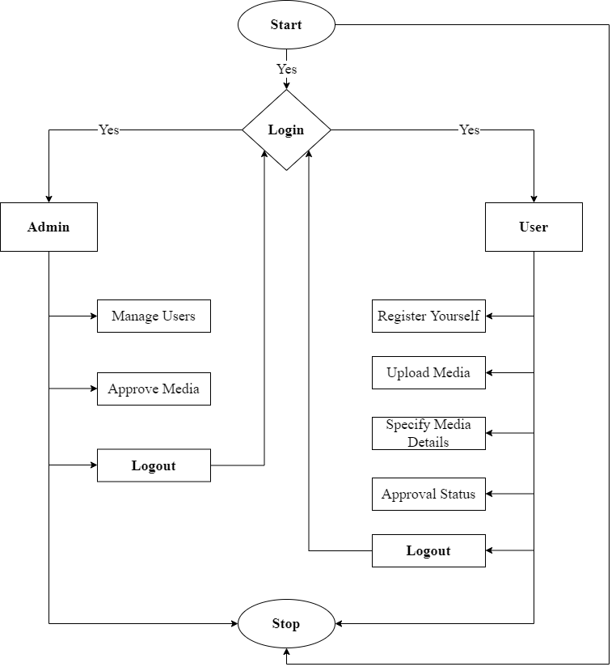

Figure 1 🡪 System Flow Diagram of Online Complaint System

**Data Flow Diagram (Level - 0)**

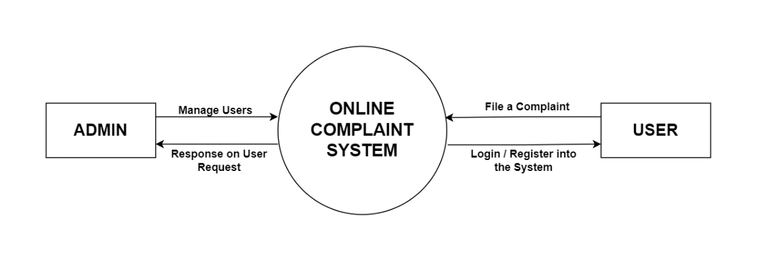

**Data Flow Diagram (Level - 1)**

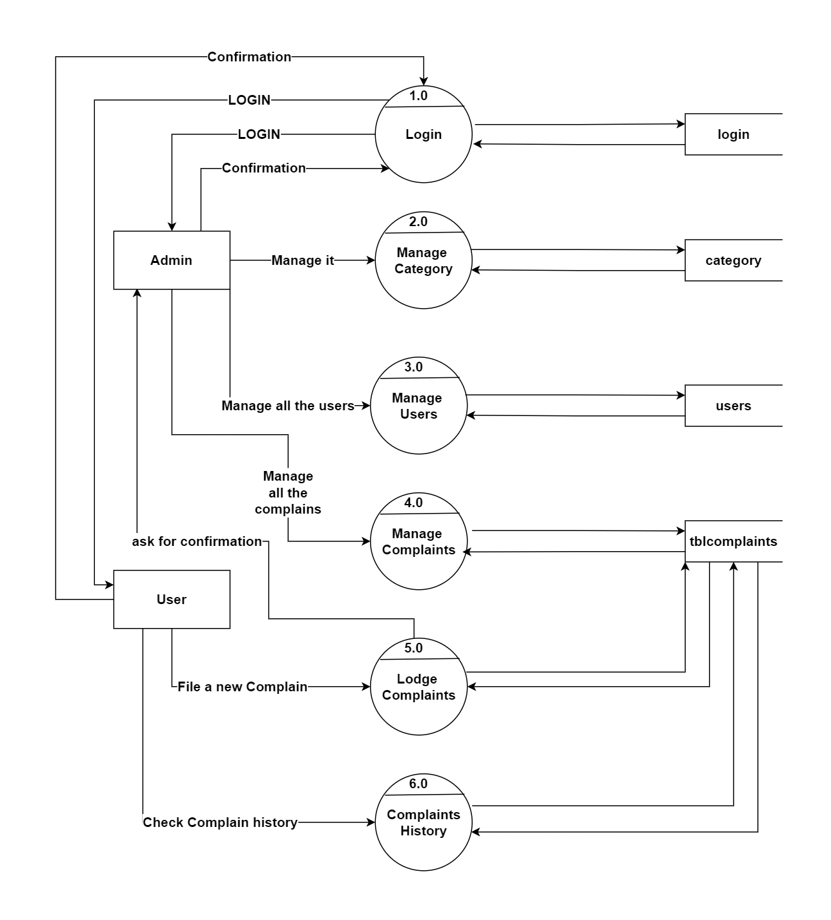

**Data Flow Diagram (Level – 2)**

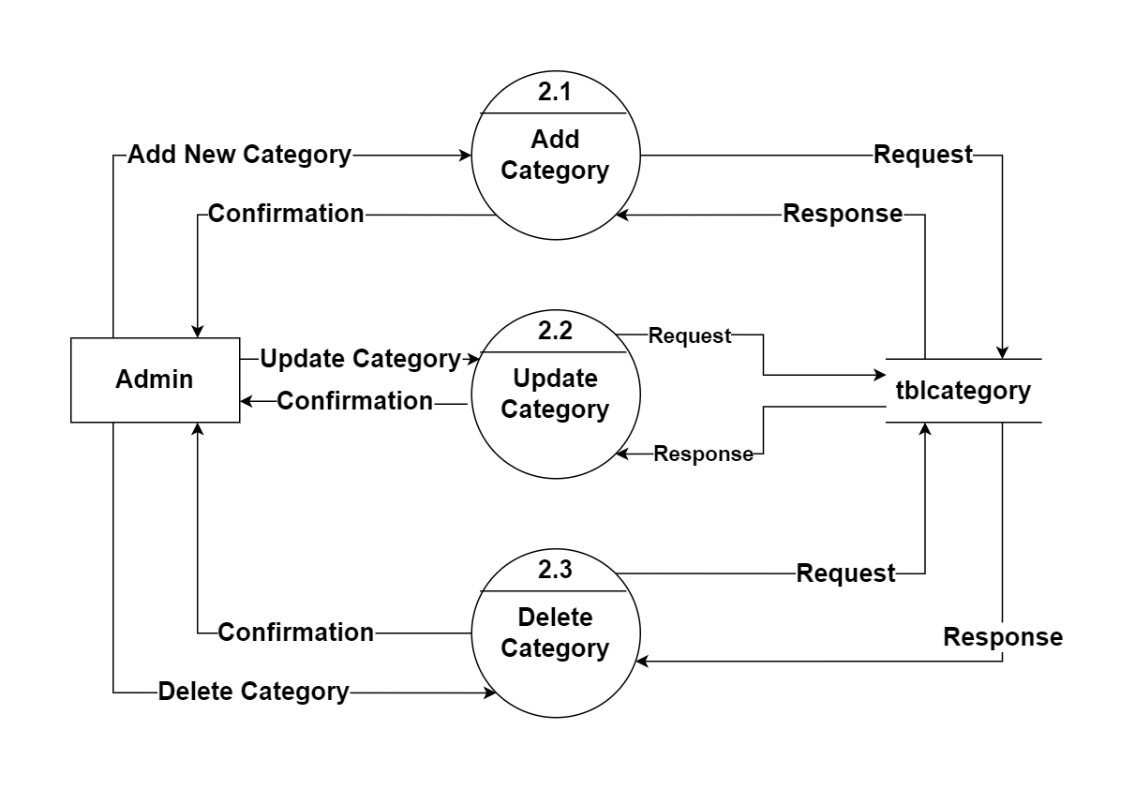

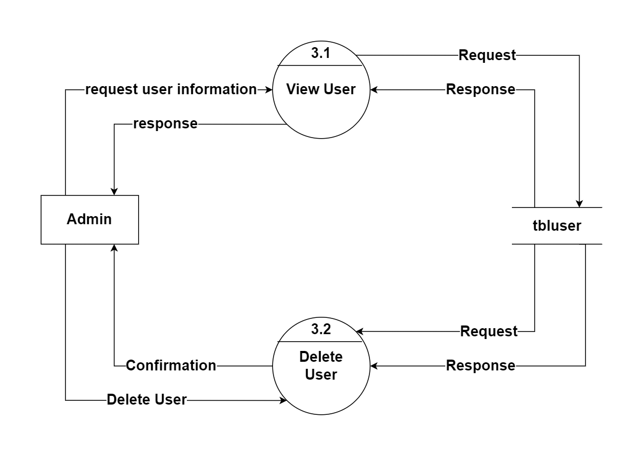

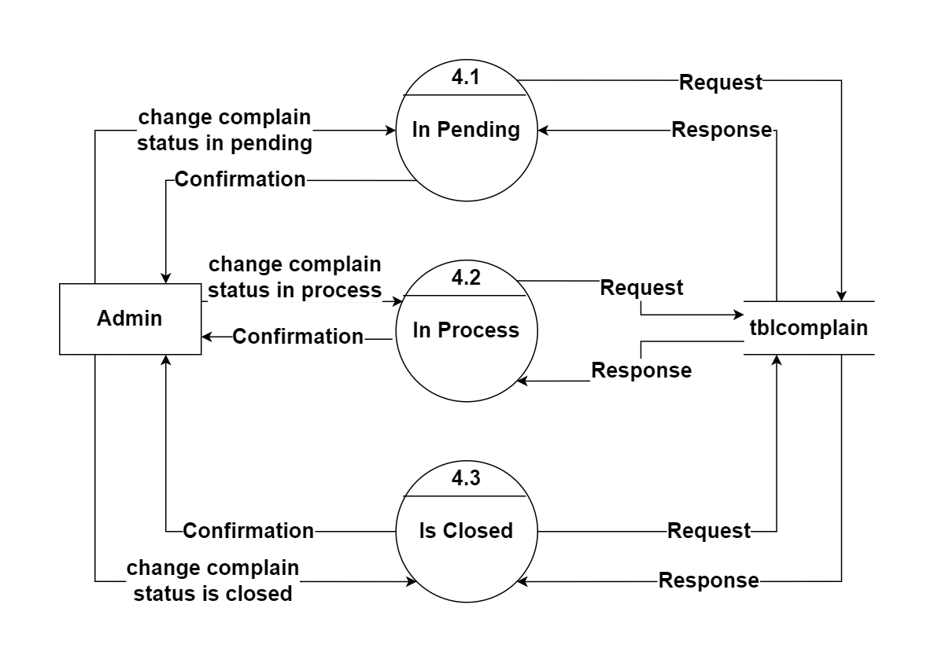

**Class Diagram**

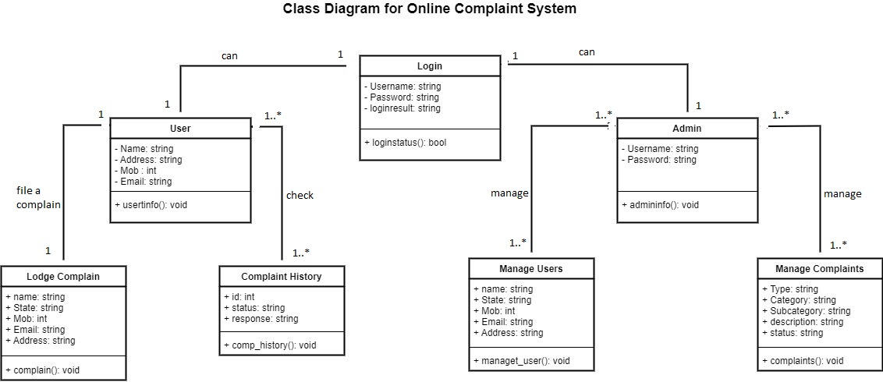

**USECASE Diagram**

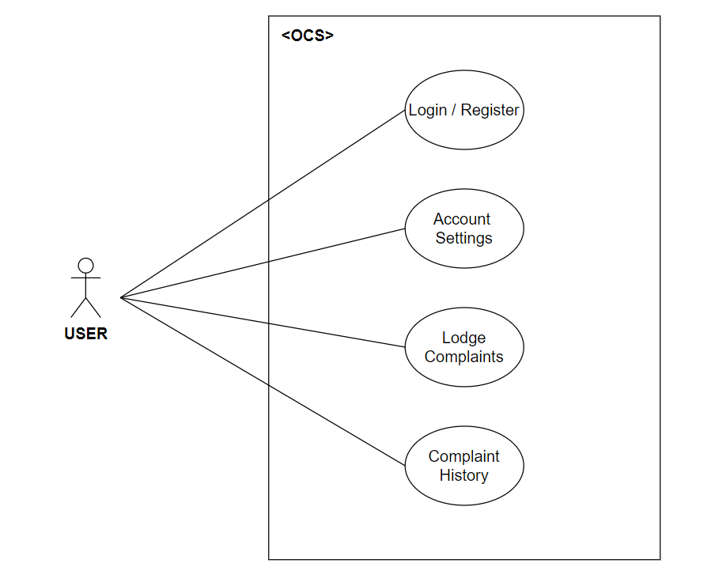

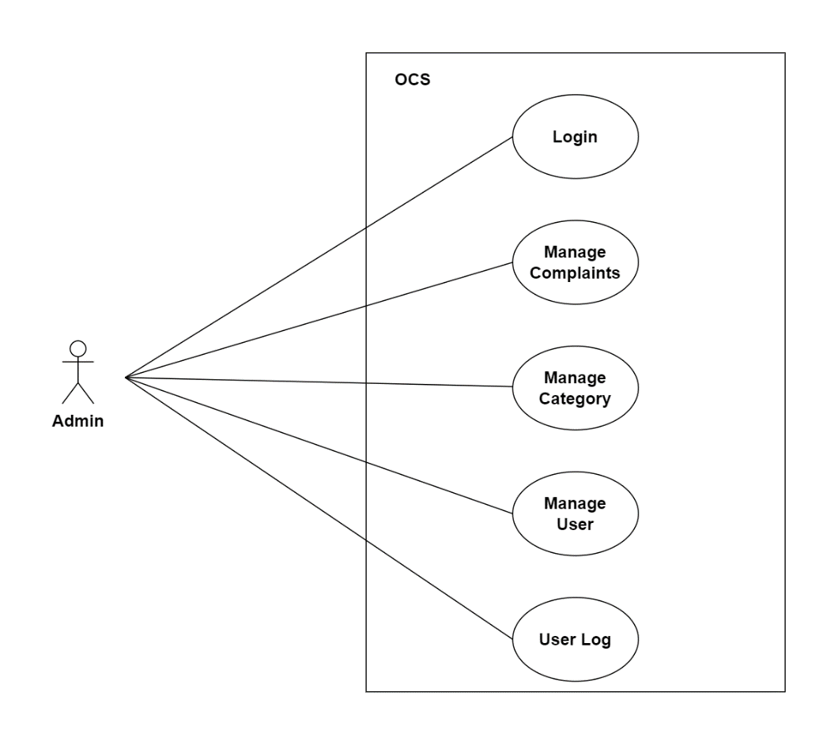

**Activity Diagram**

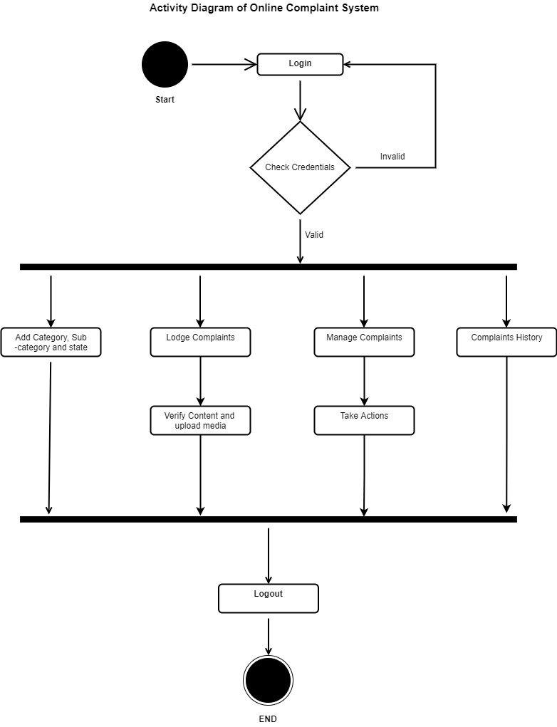

**Chapter 4**

**Data Dictionary**

**4.1 Login Table**

In this Table Program will ask the User to input correct Username and Password for Login into the System.

|  |  |  |  |  |  |  |
| --- | --- | --- | --- | --- | --- | --- |
| **Sr. No.** | **Field Name** | **Data Type** | **Size** | **Constraint** | **Description** | **Example** |
| 1. | Username | varchar | 20 | Primary Key | Unique id of Username | admin |
| 2. | Password | varchar | 20 |  | Unique id of Password | ***** |

Table 4.1 Login Table

**4.2 Registration Table**

In this Table Program will ask for Name, Username, Password, Confirm Password, Mobile Number and Email ID for register user into the System.

|  |  |  |  |  |  |  |
| --- | --- | --- | --- | --- | --- | --- |
| **Sr. No.** | **Field Name** | **Data Type** | **Size** | **Constraint** | **Description** | **Example** |
| 01 | Name | Varchar | 30 |  | Name of the User | Aman Singh |
| 02 | Email | Varchar | 20 | Primary Key | Email is Considered as Username | Amakrs21 |
| 03 | Password | Varchar | 20 |  | Valid password | ******** |
| 04 | Conf_passw | Varchar | 20 |  | Valid confirm password | Aman1234$@ |
| 05 | Mob_no | Integer | 12 |  | User Mobile Number | 9876543210 |
| 07 | Address | Varchar | 100 |  | User Address | Vadodara |
| 08 | Pin code | integer | 6 |  | Area Pin code of User | 391760 |

Table 4.2 User Registration Table

**4.3 Complaint Table**

In this Table Program will ask for Category, Sub-Category, Complain Type, Description of the Complain, and upload media if available to the System for Register a complain into the System.

|  |  |  |  |  |  |  |
| --- | --- | --- | --- | --- | --- | --- |
| **Sr. No.** | **Field Name** | **Data Type** | **Size** | **Constraint** | **Description** | **Example** |
| 1. | Complain ID | int | 10 | Primary Key | Unique id of every complain | 0001 |
| 2. | Category | varchar | 20 | Foreign Key | Category of the Complain | Cybercrime |
| 3. | Sub-Category | varchar | 20 |  | Sub-category of the Complain | Online Scams |
| 4. | Complaint Type | varchar | 100 |  | Type of Complain | Money Fraud |
| 5. | Description | varchar | 500 |  | Description of the Complaint in Details. | I have been cheated in Online Scam. |

**Chapter 5**

**Screenshot of Development Phase 1**

**5.1 Main Homepage**

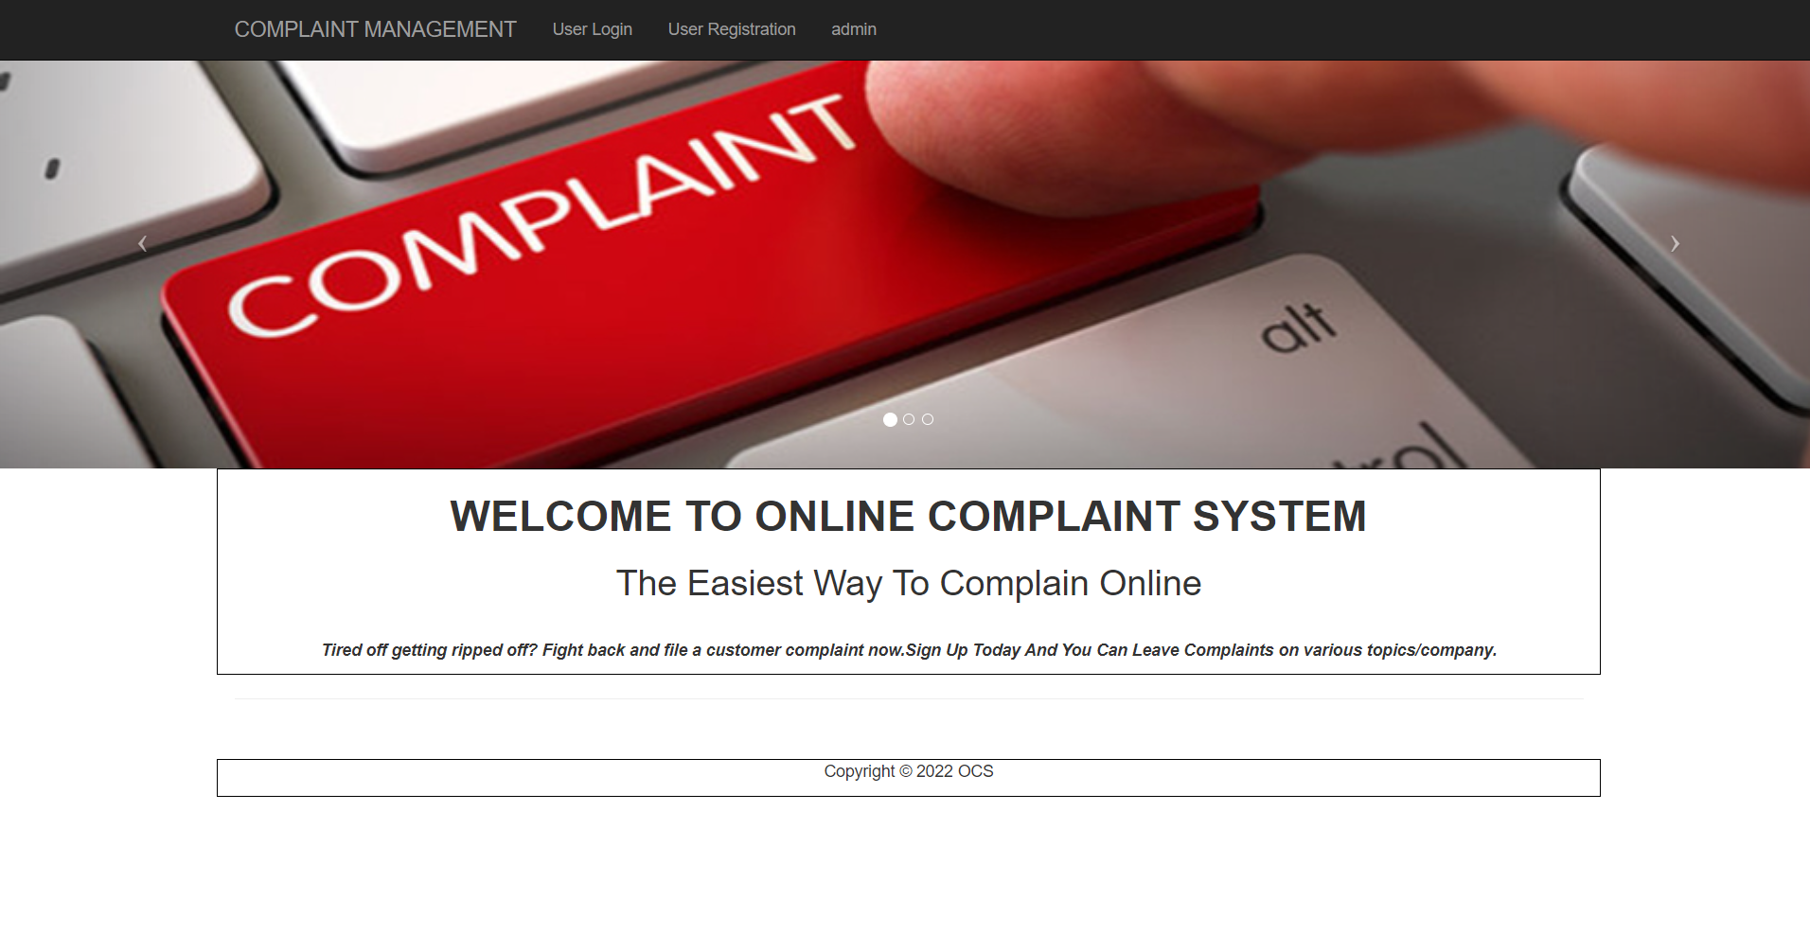

Figure 5.1 🡪 Main Homepage Design

**5.2 Code of Homepage Design**

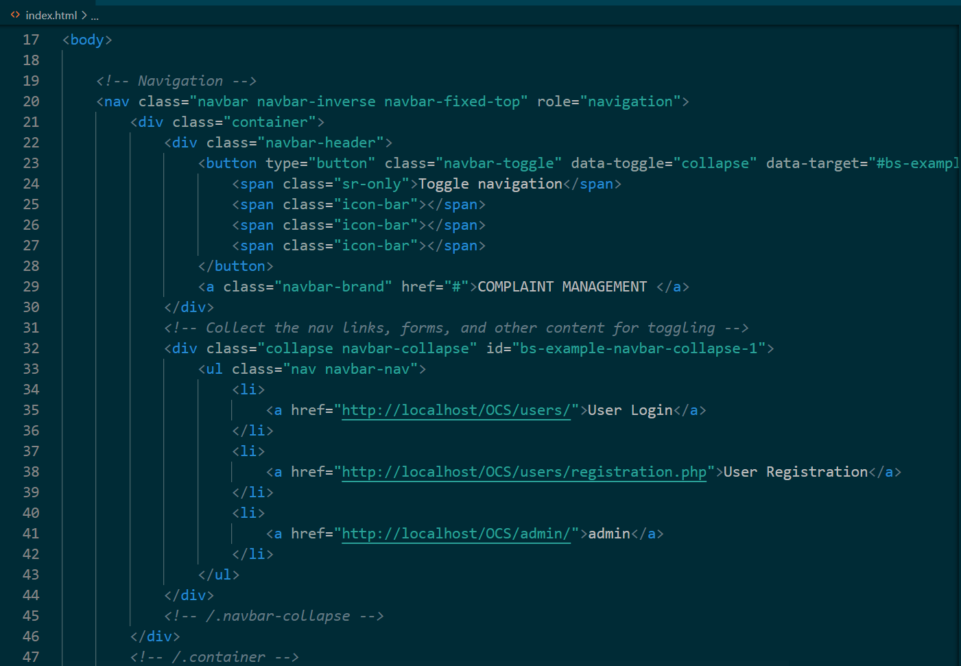

Figure 5.2 🡪 Code of Homepage Design

**5.3 Login Design**

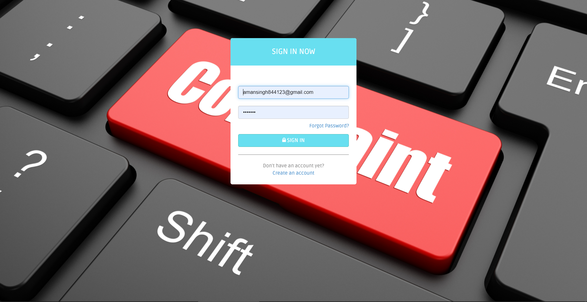

Figure 5.3 🡪 Login Design

**5.4 Code of Login Design**

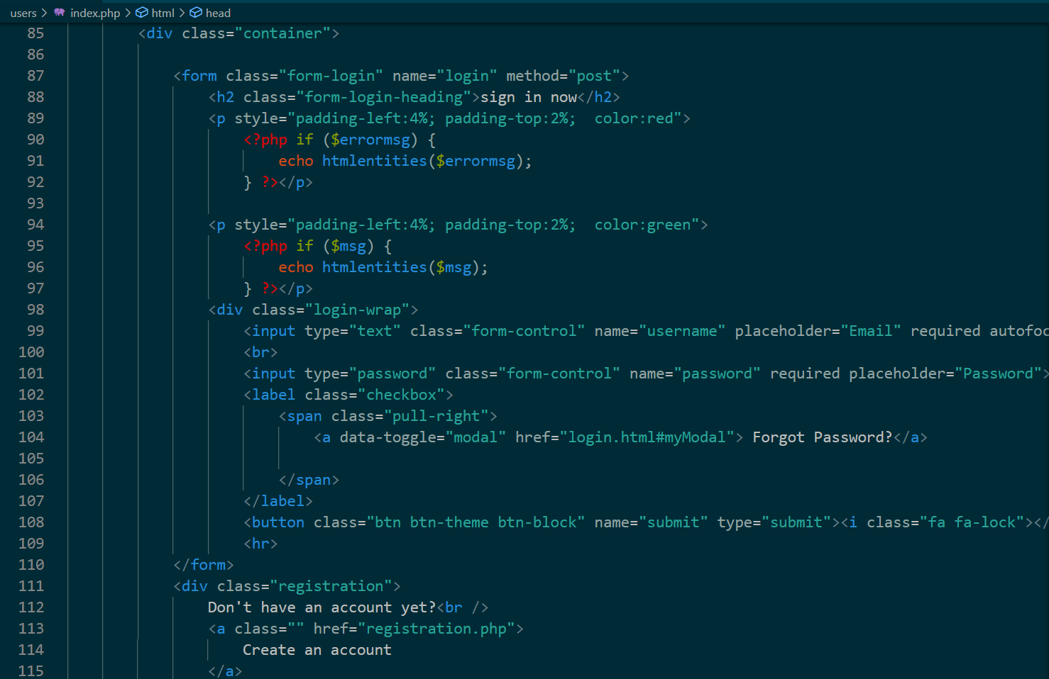

Figure 5.4 🡪 Code of Login Design

**Chapter 6**

**Screenshot of Development Phase 2**

**6.1 User Dashboard Design**

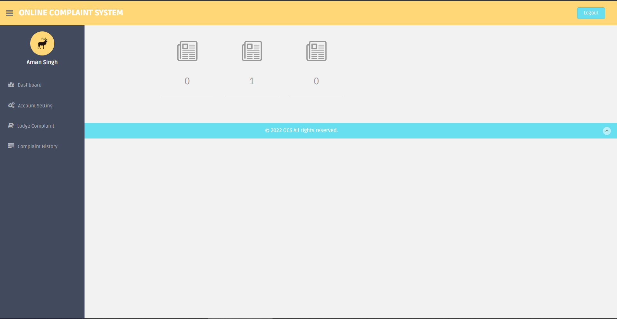

**Figure 6.1 🡪 User Dashboard Design**

**6.2 Admin Dashboard Design**

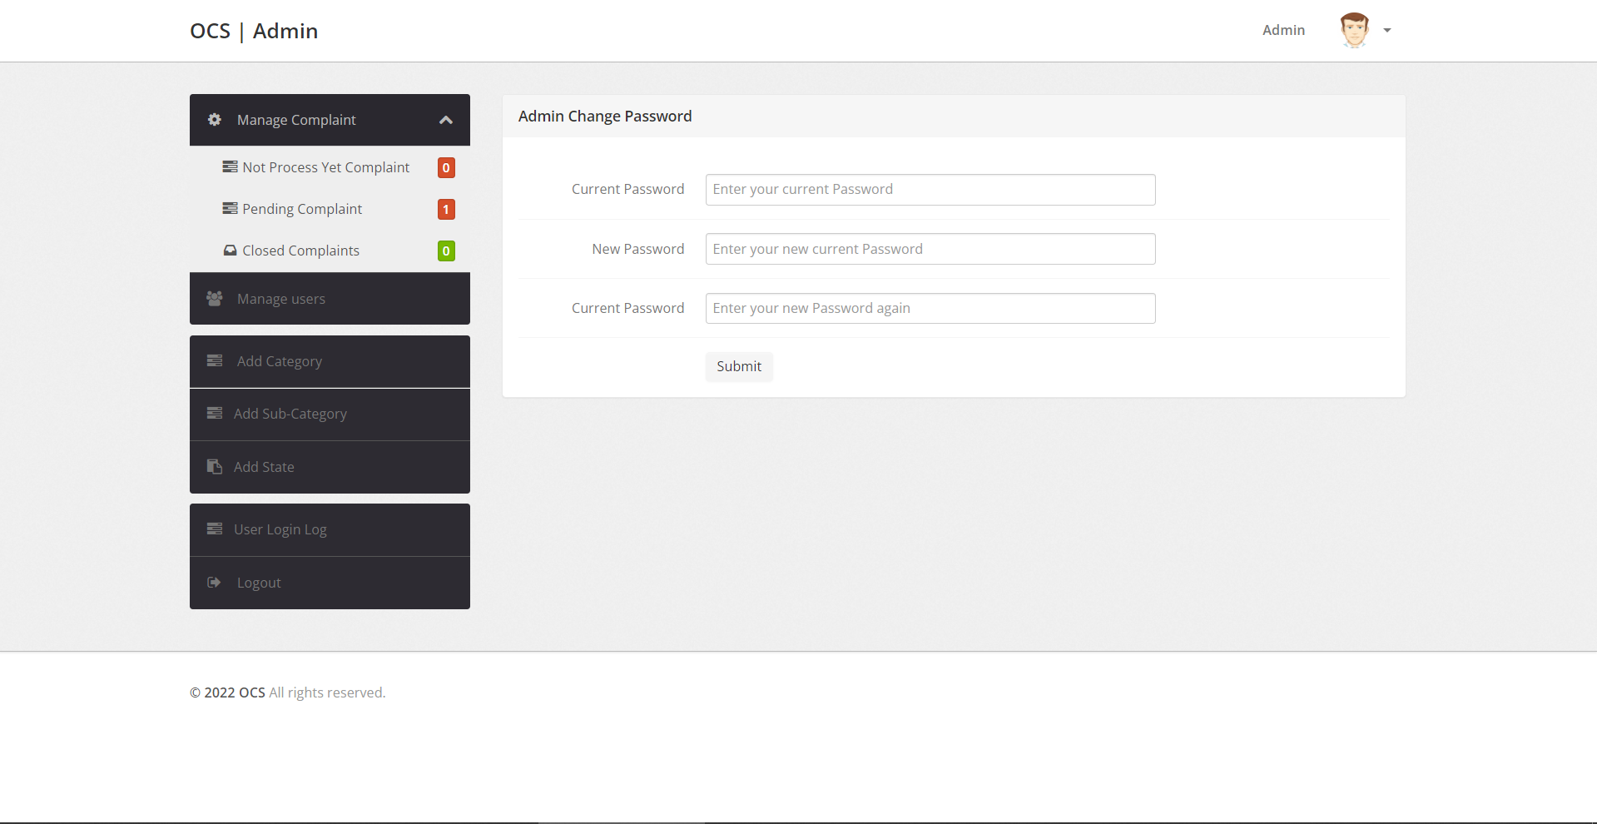

**Figure 6.2 🡪 Admin Dashboard Design**

**Chapter 7**

**Screenshot of Development Phase 3**

**7.1 Lodge Complaint**

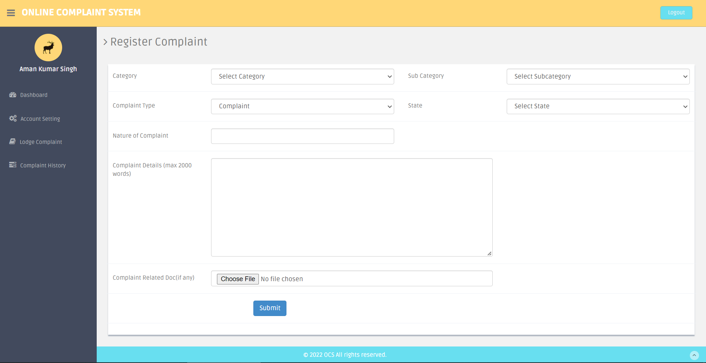

**Figure 7.1 🡪 Lodge Complain Design**

**7.2 Manage Complaints**

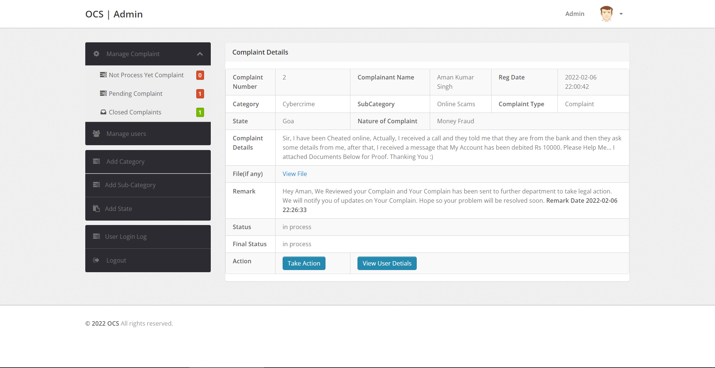

**Figure 6.1 🡪 Manage Complaints Design**

**Chapter 8**

**Conclusion**

* Our System Online Complaint System finally completed and runs with error free. At the time of developing this system we face a lot issue from starting but we didn’t stop and started finding of every problem.
* Our First problem was to connect our system with SQL Server, and it takes a lot of time to solve. We also add some features that we don’t decided previously like navigation is the Sidebar. Our system Provides a lot of features for every type of user.
* Due to use of better CSS and JavaScript, our system looks attractive and it attracts user. We try our best to make this system error free and we also tested our system more than 100 times and tried to solve every small issues. And we can proudly say our system is 99% error free, there is only lack of some Features that we will add in Future.
* Finally, we built a working website in which user can easily register in it, and they can easily use all the features which is provided by the system.
* This System is fully secured, because on each login user required password and their login activity is saved along with their IP address.
* This system currently works manually using admin, for verify the Complaints of the User and send response on their complain.

**Chapter 9**

**Future Enhancement**

* Firstly, we will add email ids of Government and Media (Local and National Media), so Complain will also being public and user get a better and fast solution.
* We will add automation using Machine Learning techniques that reduce the burden of admin to always verify each complain of the user.
* After we will improve the UI of this System that will give a better experience to the User’s.
* If this system will popular among the public then we will buy a fast and strong server which prevent this website from crash and it will also provide a good security to this System.

**Chapter 10**

**References**

Website:

1. <https://www.php.net/docs.php>
2. <https://dev.mysql.com/doc/>
3. <https://github.com/>
4. <https://stackoverflow.com/>
5. <https://www.quora.com/>
6. <https://docs.microsoft.com/en-us>
7. <https://www.geeksforgeeks.org/>
8. <https://www.khanacademy.org/>

Book:

1. PHP in Advanced
2. SQL Beginners Guide

Other Resources:

1. Some Journals
2. YouTube